Saturday 17th August
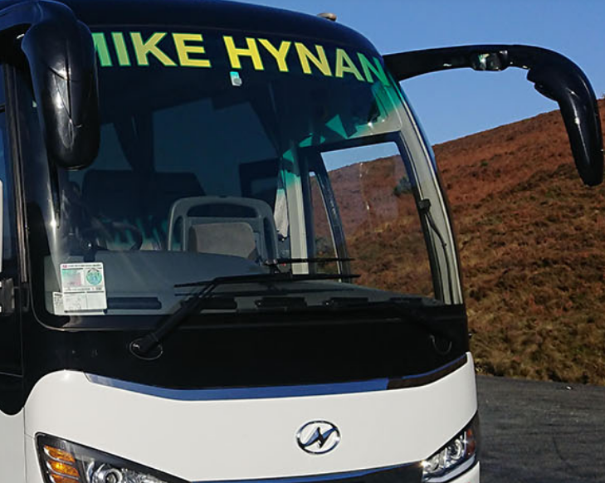
Free Bus to Cappamore Show
From Cappamore, Doon & Murroe
Cappamore - Times
Pick Up outside Community Centre @ 12pm, 1pm & 2pm

Doon - Times
Pick Up in Car Park Opposite Graveyard & Lysaght’s Cross @ 12pm & 1.15pm

Murroe - Times
Pick Up at Monument @ 12.30pm & 1.45pm

Return buses for all locations are from 5.30pm from showfield.


